JavaScript Exercise

# The objective

The idea of this exercise is that you learn how to use JavaScript in your web applications. After completing this exercise you should know how to handle events like onload, onclick how to manipulate DOM and how to use JavaScript objects.

# Exercise

Use myscript.js file to complete next tasks.

1. Append basic onload event handling in your JavaScript file. When onload event is triggered print the ‘event’ object in console. Use browser debugger to investigate the event object.
2. What is a difference between document.onload and window.onload? Why it is important to handle one of these events?
3. Append a button in your web page below the pictures in London <section>. Add next functionality to button: when the button is pressed all the plain text (all <p> elements) font size is changed to 20px (for the bad eyes of course) in London <section>.



1. Change the previous functionality so, that if user pushes the button and the font size is 20px it goes back to 16px.
2. Append a new button to your form element (see next page picture for more info). Create a new JavaScript Object (you can decide the syntax how you create that object. Object contains two properties fact and details both are arrays. Example

var factObject = {

fact:[],

details:[]

}

When user pushes the Button Save Fact (that you previously appended) the information from the form is stored in your object. The input text from fact field is stored to fact[] array and the details to objects details[] array. You can append new items to your array object as follow: factObject.fact.push(“some”) and factOject.details.push(“akdjadskj”);

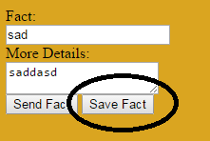

1. Append next extra functionality. When user presses Save Fact button, the information from the form elements are appended in to the table you have. This is a little bit tricky, but you can handle it!

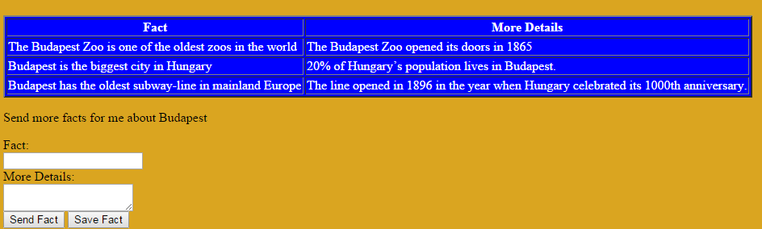

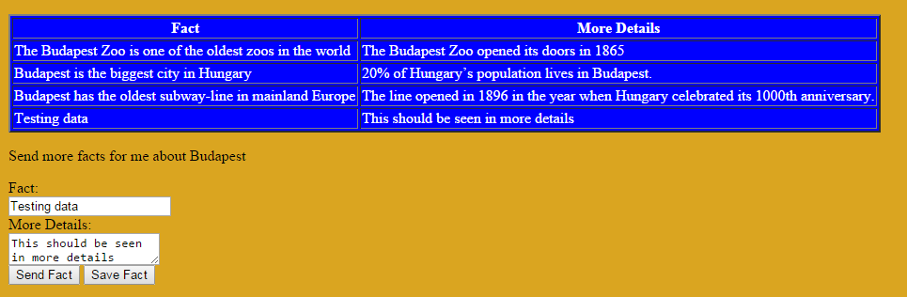

1. This is complicated but try it still. When user clicks a row in the table, that row is removed from the DOM. Ask trainer help for this if you stuck for too long time.
2. Use JSLint tool to verify your code: <http://www.jslint.com/>